# AVANTIKA UNIVERSITY

# Avantika_Logo.svg.png

Product and Brand Management

Assignment – 02

BBA 5th Sem

Brand Building

Submitted by - Submitted To -

Yusuf Pipalrawanwala Dr. Ankur Kumar Rastogi

* **Executive Summary -**

Smart Bags is a local government manufacture firm located in Ujjain and has gradually nurtured a brand of selling durable, fashionable, and affordable bags into the hands of various kinds of consumers. Beginning with the description Since the start in 2015, the company struggled to enter a market dominated by developed national with significant costs of entry. Hardly had Smart Bags overcome these obstacles, when it gained some level of favor within its own community through the quality and steadiness of its product prices.

This report will provide a detailed plan that will help change Smart Bags into a top brand in the region. The strategy brings in a combination of market research, consumer information, pricing model, brand building, celebrity sponsorship, cyber marketing communications, and PBM models (CBBE, Aaker, BCG, PLC). It focuses on emotional narratives, culturally relevant, and digital three factors making Smart Bags a multi-purposed functional and aspirational brand that gains immediate loyalty and builds up long-term success.

* **Company History and Introduction of the Business**

*Launch & Initial Challenges (2015)*

Smart Bags were launched in 2015, and it had a small retail shop in Ujjain in Bada Sarafa and in the same location it had a local production unit. The brand planned to sell long-lasting but cheap bags to many of the segments, including school kids, college students, travellers, and corporate people.

*Challenges at Launch:*

* It is anticipated that CRM should be offered through premium brands like VIP, Safari, and newer brands such as Sky bags: all of which were known in the country in terms of design and quality.
* It was challenging to compete with local unbranded players offering lower prices. (Bagscraft, Avantika Bags, etc.
* Lack of Awareness The lack of marketing and digitals meant that the brand was not known outside the local market.
* Product Diversification: Striking a balance between affordability, trendiness, and longevity on several fronts proved a difficult task operationally.

*Current Status*

Despite its initial difficulties, Smart Bags has realised:

* Already existing customer base in Ujjain and neighbouring towns.
* Appreciation of permanency, making it the favourite brand of parents and students.
* The retail outlet is generating the steady sales and B2B sales are good.

*Opportunity for Growth*

The strategies scheduled in this report are to:

Extend market scope in the region.

* Increase brand awareness via celebrity promotion and electronic advertising.
* Create emotional attachment to consumers through storytelling, nostalgia and societal integration.
* Expand product ranges into environmentally friendly, high-end and small-volume merchandise.
* **Images of Manufacturing Site, Warehouse and Retail Store –**

**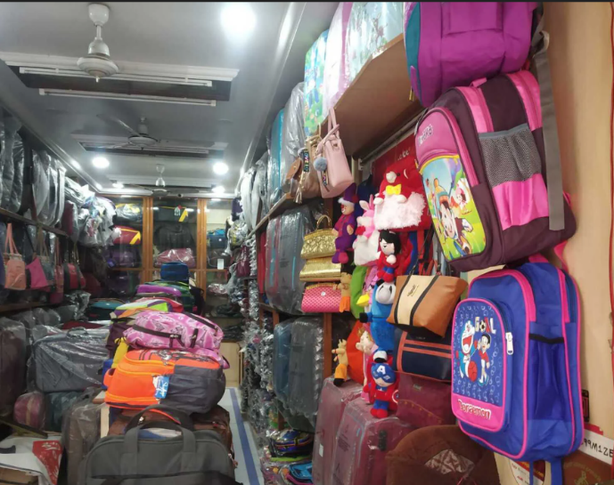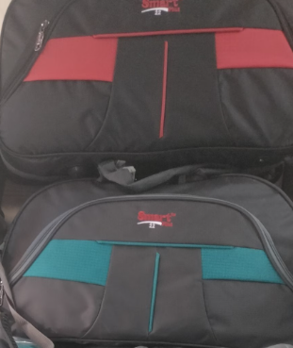**

**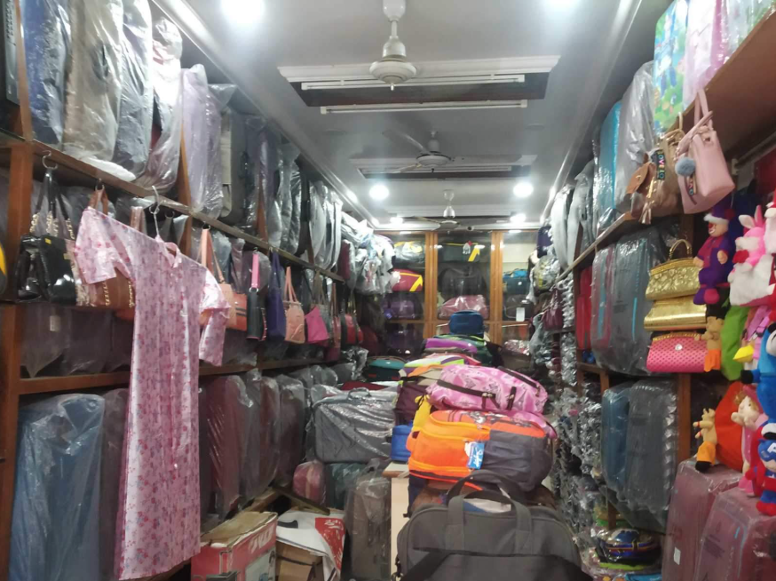**

**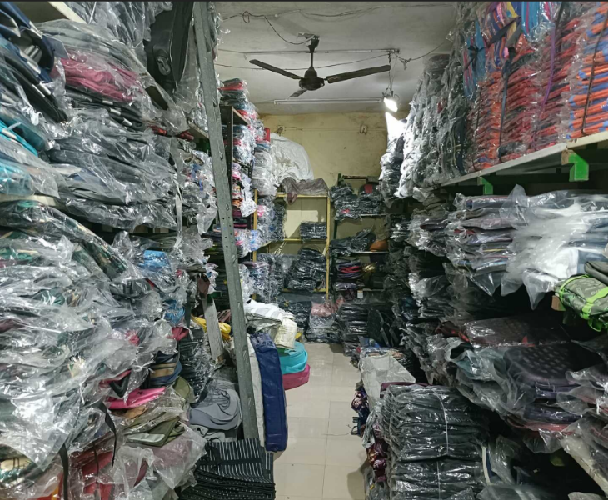**

**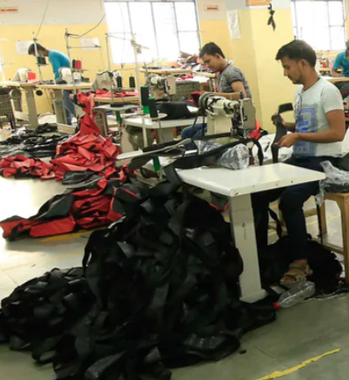**

**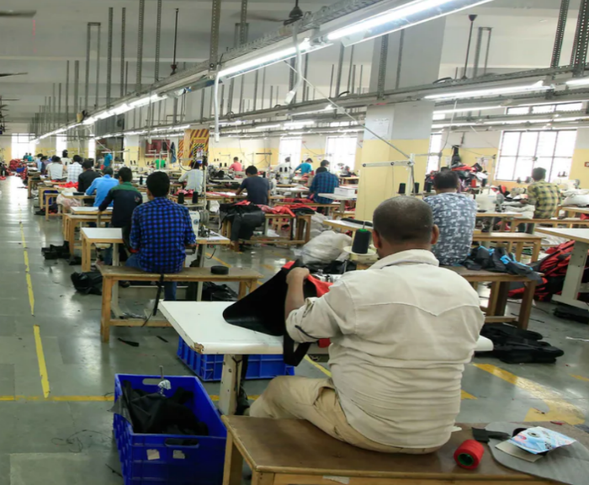**

* **Market Analysis**

*Target Segments & Insights*

Kids (School Bags)

* The requirements are quality and longevity, cost-efficiency, striking prints, support, and easy weight.
* Insight: Parents are the main consumers; they are much more sensitive to the durability of the value and safety, and the repeated purchase is usually made by parents every 12-16 months.
* Old Images –

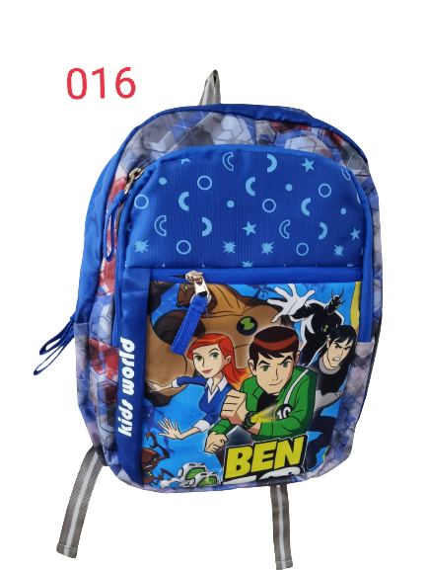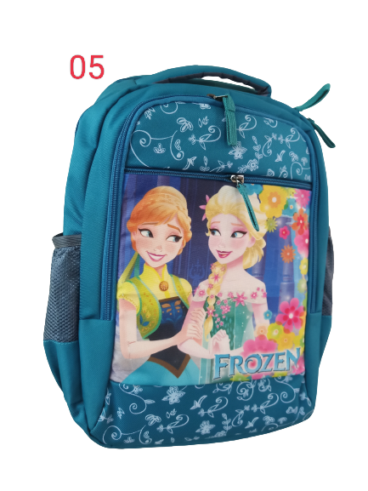

Youth (College Bags)

* Required features: Fashion, performance (laptop sleeves, USB charging devices), brand image.
* By the numbers: students want canvas bags that are fashionable, Instagram-shot worthy, and useful. They are ready to spend a reasonable fee on products that are stylish, fashionable, and convenient.
* 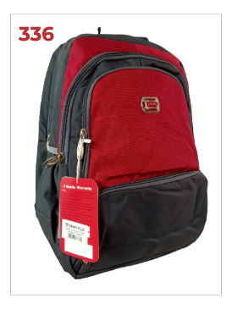Old Images -

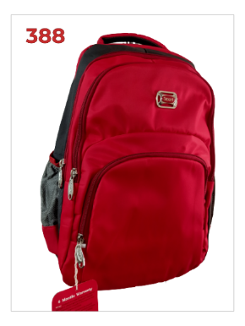

Traveler (Suitcases and Travel Bags)

* Requirements: Strength, space, mobility (wheels/on trolley), fashion.
* Insight: Infrequent travelers who demand quality and longevity and who are oriented to excellence in their travelling activities and can afford it.

Office Office bags Laptop Bags Professionals

* Features: Shiny design, minimalistic size, luxurious materials, practicality.
* Niche buyers tend to consume the product due to their perception of high professionalism, aesthetics, and long-life span instead of the price.

*Non-business-related Consumer Insights- Ujjain and Nearby Towns*.

* Consumer believes in local products, which are durable yet affordable.
* USP: Smart Bags products have a years-long lifespan, and they produce a strong word-of-the-mouth recommendation.
* Parents and students, the brand is upgraded frequently because of reliability, which drives repeat purchase behaviour.
* **Competitive Analysis**

|  |  |  |  |
| --- | --- | --- | --- |
| Competitor | Segment | Price Range | Positioning |
| VIP, Safari, Skybags | Premium school & college bags | ₹1,500–₹3,500 | Praised as national brands; but costly |
| Domestic/unbranded | Budget school bags | ₹250–₹700 | Very cheap, low quality, not reliable in terms of longevity. |
| Smart Bags | Reasonable middle-range | ₹600–₹2,500 | Good, flexible, well made; business-friendly between domestically produced incredibly cheap and luxurious items. |

* **Strategy Implication**:

Smart Bags is not just in the lower end, whereas unbranded local and high-end national competitors, as it occupies the more affordable, timeless and durable niche, with a higher value offer providing an excellent balance between cost, quality and the design, which can be considered its strength.

*Brand Positioning Statement*.

Smart Bags provides fashionable, reliable, and low-priced bags that will last the test of time to the students, family and travelers than competitors who just contend with losing their trust with the locals.

Logo Creation –

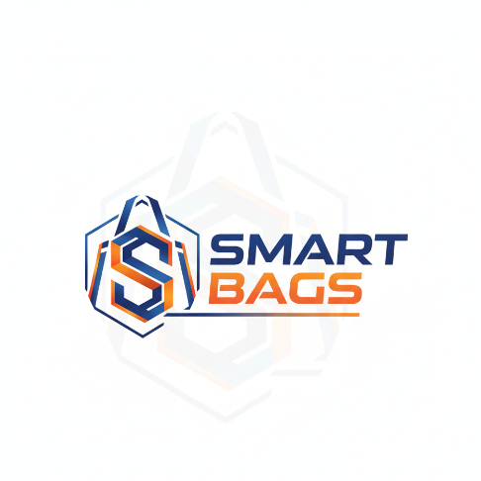

Rationale:

* Makes a distinct distinction between Smart Bags on the one hand and domestic goods and luxury national brands on the other hand.
* Emphasizes market product features (mail service, requirements, quality, image) and product emotional values (confidence, tradition, crossing generational).

*Celebrity Brand Ambassador Strategy*

A strategy will involve the use of celebrity brand ambassadors.

Ranveer Singh is chosen because of his young, energetic and relatable character, which also matches exactly the focus market of Smart Bags: students and young adults.

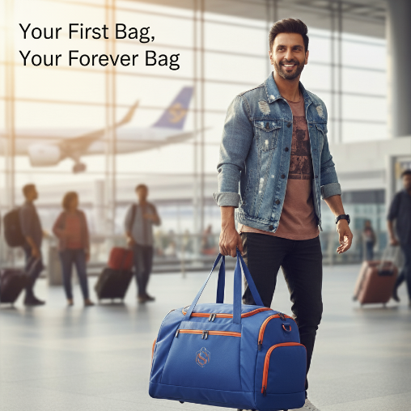

**Campaign - Express Yourself:**

* Instagram reels, YouTube videos, Tik Tok challenges where durability and style are shown.
* On-Ground: Selfie booths and bag-testing challenges with giveaways at colleges.
* Limited Edition Co-Branded Bag: Small batch Relates to Ranveer Singh and his fashion and personality.

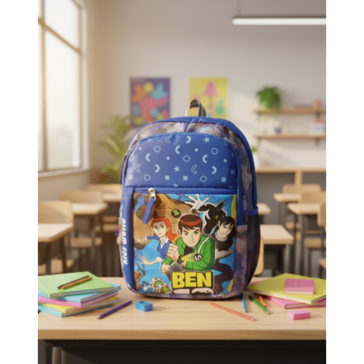

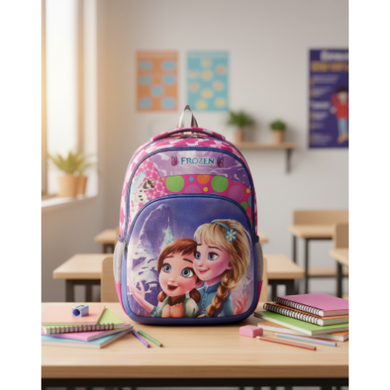

*Expected Outcomes*:

* More brand recognition and mechanics.
* Perspectives on being fashionable and young are boosted.
* Viral marketing user-generated content.

*Emotional Branding and Storyful.*

**Campaign Idea**: Your First Bag, Forever Bag.

* Causes a sense of nostalgia, a sense of loyalty, displays Smart Bags at different life periods: childhood, college, travel, adulthood.
* 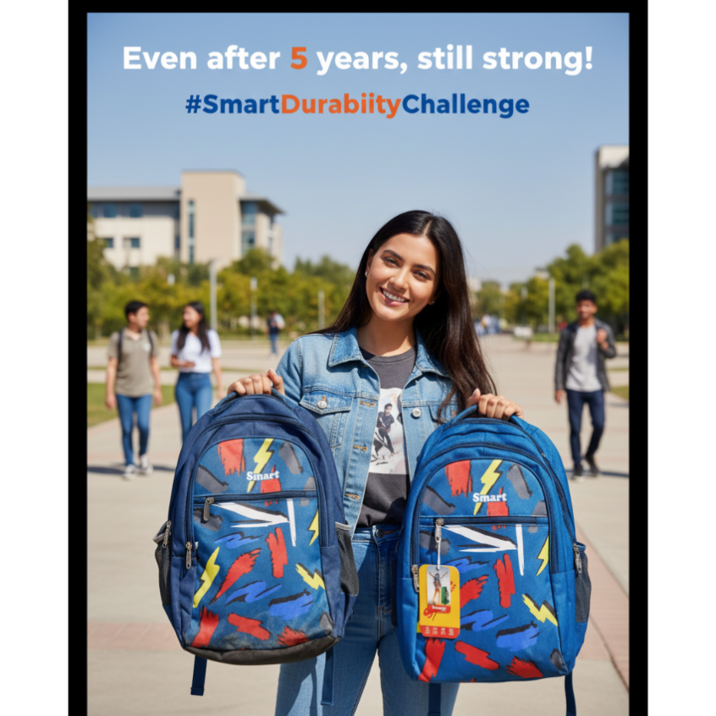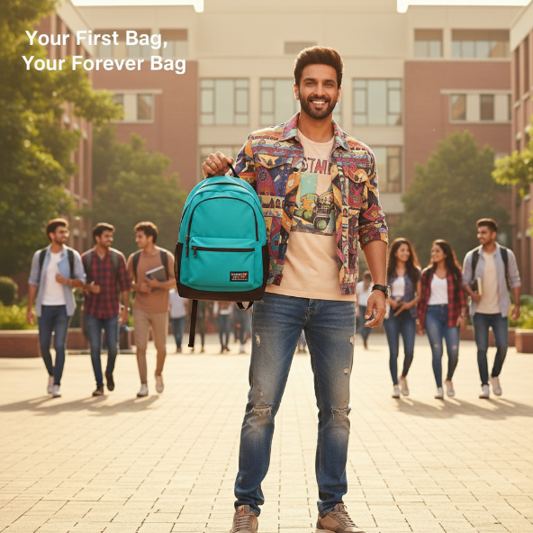Customer-created content: #SmartStories will invite consumers to share their Smart Bags experiences.

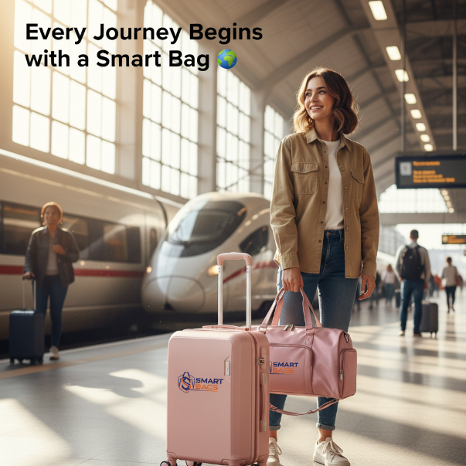

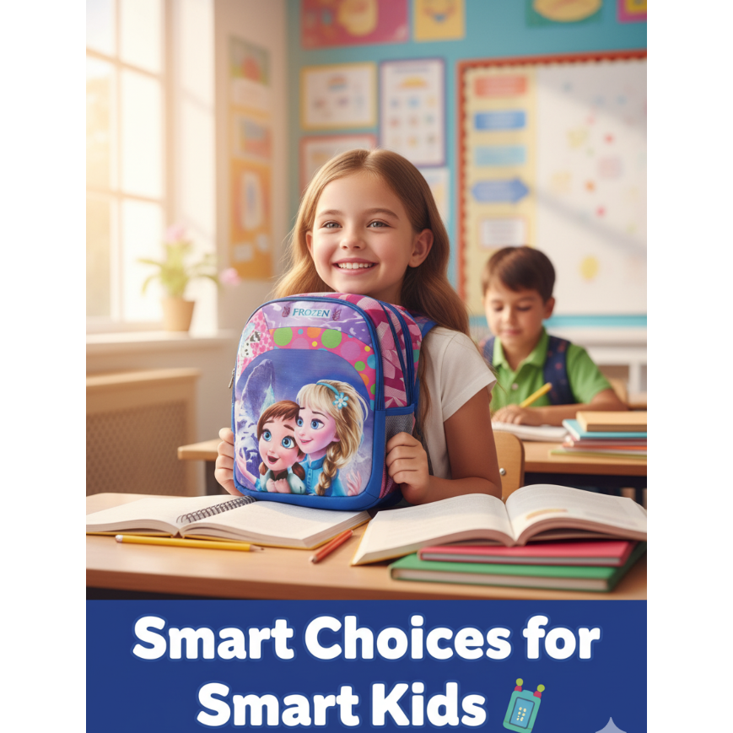

*Cultural & Regional Tie-Ins:*

* Small collections bearing Mandu/Mahakal centralizations to build in local pride.

*Brand Mascot:*

• Mr. SmartPack - a social media, retail story and funny character attracting children.

* **Digital Branding and Social Media Strategy**

*Digital Presence Goals*

* Awareness: Become a household name in Ujjain and adjacent towns, Make Smart Bags.
* Engagement: Promote user-generated material by use of challenge, story, and reel.
* Conversion: Increase the online purchases and foot delivers into the stores.

*Key Campaigns*

|  |  |  |  |
| --- | --- | --- | --- |
| Campaign | Concept | Platform | Expected Impact |
| Smart Durability Challenge | Show old vs. new bags surviving extreme use | Instagram Reels, TikTok | Viral content, demonstrates durability |
| Back-to-School Carousel | Bright, playful visuals of school bags | Instagram, Facebook | Engages parents and kids, boosts seasonal sales |
| Travel Campaign | Scenic travel photos with bags | Instagram, YouTube Shorts | Targets young travelers, builds aspirational value |
| Community Stories | #SmartStories – consumers share experiences | Instagram, Facebook | Nurtures emotional connection and loyalty |
| Festival Promotions | Bright festive posts + discounts | Instagram, Facebook, local WhatsApp marketing | Boosts short-term sales and visibility |

*Content & Design Guidelines*

* Voice: Approachable, trustful, inspirational.
* Hashtags: #SmartBags #CarrySmart #SmartDurability BagsForEveryJourney.
* Visual Identity: Smart Hybrid (trust) Bright Orange (energy), G/B (durability) Royal Blue.
* 3-4 posts a week + seasonal campaigns and influencer tie-ups.

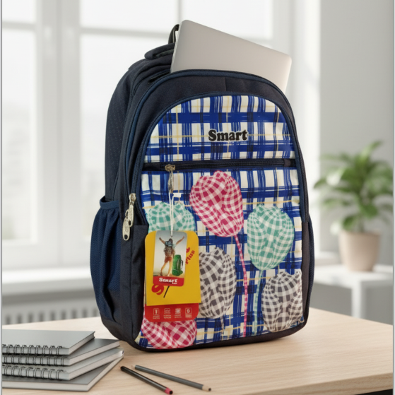

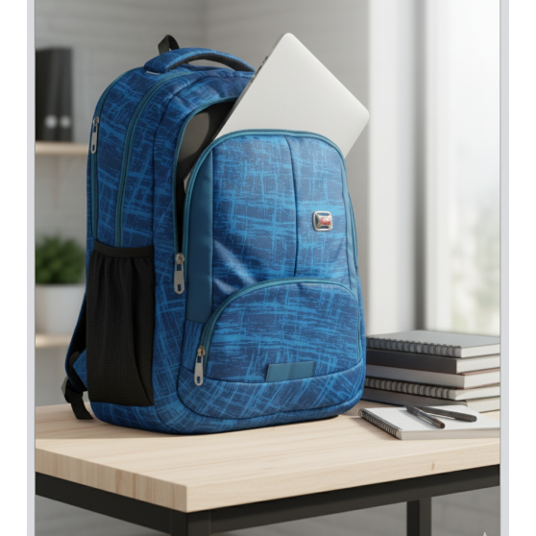

*Expected Results*

* Increased interaction between parents and younger individuals.
* Strengthened brand recall.
* The buzz on social media will increase the credibility of future expansion of the region.
* **Creative Branding & Retail Strategy -**

*Retail Store Concept*

**Flagship Store ( Bada Sarafa): a Bag Gallery idea**.

* Selfie-friendly corner
* Bag journey fabrics in the early years of childhood till maturity.
* Focus on durability through visual advertising.

**Visual Merchandising**

* Good segmentation: school, college, travel, professional.
* Short-term & seasonal displays.
* QR codes with interactive links to social attempts.

*Packaging & In-Store Branding*

* Green carry bags and tagline printed.
* High-end bag covers under the brand name.
* Below: Using advertising banners: Mr. SmartPack impresses the children with the mascot.

*Experiential Marketing*

* College activations, bag lifestyles competitions.
* Partnership with schools, workshops, giveaways.
* Local community events & festivals.

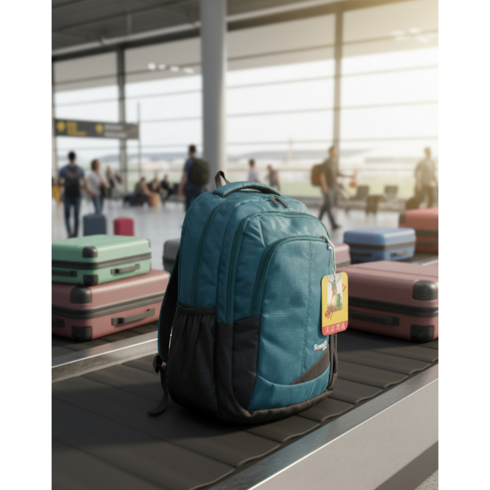

*Deliverable*

Adds brand perception and feeling of attachment across the age groups.

* ***3-Year Growth Roadmap***

|  |  |  |
| --- | --- | --- |
| Year | Focus Areas | Actions |
| Year 1 | Brand equity and Domestic recognition | Possess logo and tagline; social media promotion; store revamp; #SmartDurabilityChallenge. |
| Year 2 | Digital Expansion & Youth Engagement | College activations; limited edition designs; Ranveer Singh tie-up; influencer tie-ups. |
| Year 3 | Regional Presence & Product Diversification | Expand to larger cities/ towns; green bags; collaboration with schools/ colleges; new high-end product line. |

Reason Rational include ensured controlled growth, increased brand loyalty, and maximization of profitability on marketing activities.

* **PBM Frameworks Application**

*Customer-Based Brand Equity (CBBE) of Keller.*

|  |  |  |
| --- | --- | --- |
| Stage | Smart Bags Insights | Explanation |
| Salience | Decent local recognition; known to be strong in terms of longevity and cost efficiency | Whenever people think of bags, they recall the brand immediately |
| Performance | Long lasting, affordable, useful designs | Strengthens customer satisfaction and reliability. |
| Imagery | The Family-friendly, aspirational, and local pride | Emotional links; attracts parents and youth. |
| Perceptions & affection | Intelligent buying; nostalgia, pride | Customers feel value and make repeat buying |
| Resonance | Drive to buy again, Digital engagement, Improved community loyalty | Great brand attachment; activities such as #SmartStories can enhance this attachment. |

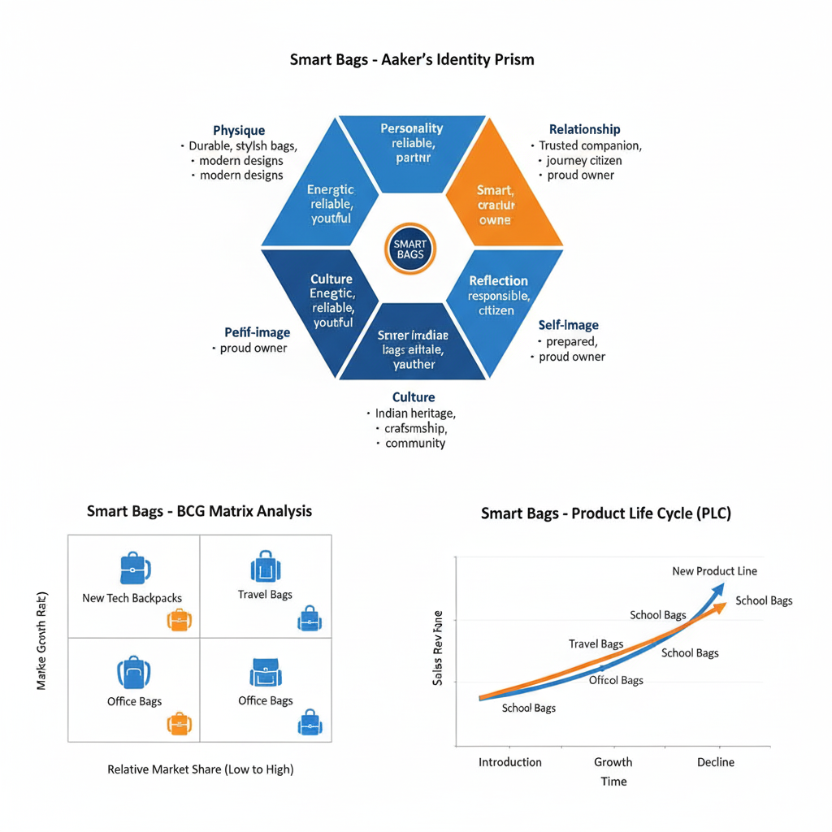*Aaker’s Brand Identity Prism*

|  |  |  |
| --- | --- | --- |
| Aspect | Smart Bags Implementation | Detailed Explanation |
| Physique | Wide product range | Corporeal element of brand; adaptable, life stages. |
| Personality | Youthful, dependable, friendly, energetic | Makes the brand more user-friendly; will attract both parents and students. |
| Culture | Local roots, customer-first philosophy | Earns trust and credibility |
| Relationship | Companion across life stages | Life stage companion over campaigns through storytelling. |
| Reflection | Parents: smart purchase; Students: trendy & reliable | Reflects self-image of consumers |
| Self-Image | Consumers feel responsible and stylish | Consumers like advocacies and increases loyalty. |

* ***BCG Matrix***

|  |  |  |  |  |
| --- | --- | --- | --- | --- |
| Product Category | Market Growth | Market Share | Classification | Strategy |
| School/College Bags | High | High | Star | Continue investment; utilize the B2B and retail channel. |
| Travel Bags | High | Moderate | Question Mark | Invest in the marketing and enhance the distribution regionally |
| Suitcases | Moderate | High | Cash Cow | Maintain moderate profitability; short duration innovation. |
| Professional/Office Bags | Low | Low | Dog | Reposition as niche premium/phase out |

Explanation:

* Stars: Need investment to continue expansion and to still see the brand.
* Question Marks: Already high chances contributed need intensive marketing.
* Cash Cows: Proven products; are profitable with little investment.
* Dogs: There is low rate of growth, these can be divested or repositioned.

*Product Life Cycle (PLC)*

* School Bags/College Bags: Maturity Refresh design, colours, limited editions, and seasonal marketing.
* Travel Bags: Expansion Expand into the digital space My digital campaigns and influencer relationships.
* Suitcases: Maturity: Mind sales; General material/functional innovation.
* Office Bags: Retrenching/ Avoiding: Change position/ Phase out; launch ecofriendly high-quality bags.
* **Pricing Strategy Competitive Positioning**

***Pricing Overview -***

To target multiple consumer groups and preserve the value, Smart Bags embraces a lower-to-higher price strategy. Pricing has been aligned according to quality and functionality and market segment expectation.

|  |  |  |  |
| --- | --- | --- | --- |
| Product Category | Proposed Retail Price | Key Features / Justification | Competitive Edge |
| Nursery / LKG / UKG School Bags | ₹250–₹600 | simple zippers, simple prints, lightweight | affordable entry point of the segment; first-time buyer; low-end competition |
| Standard School Bags (Grade 1–5) | ₹600–₹1,200 | Better padding, water-resistant fabric, multiple compartments | Provides the right price to people; has an appeal to those parents who consider sentiments of long life. |
| College / Youth Backpacks | ₹1,200–₹2,500 | Laptop sleeve, USB charging port, ergonomic design, trendy prints | Mid-tier positioning; superior design vs. local competitors |
| Travel Bags / Duffel Bags | ₹2,000–₹4,000 | Larger sizes, reinforced base, durable straps, optional wheels | Bridge the gap between cheap domestically made bags and high-end brands |
| Suitcases / Hard-Shell | ₹3,500–₹7,500 | Spinner wheels, telescopic handle, lock mechanism | Affordable higher quality; other brand as dependable travelling. |
| Premium / Specialty Line | ₹8,000–₹12,000+ | Leatherette, designer collaborations, limited editions | High-end brand positioning: small run streamlines exclusivity |

*Pricing Tactics*

1. Entry -Upgrade Path: Tiered pricing is ideal because it will promote repeat purchasing when a child matures or a student advances.
2. Wholesale Pricing: School and college orders are encouragement of large institutional customer relationships.
3. Bundling Offers: MYOB – Buy a school bag + lunch box/ lunch bag at a slight discount.
4. Seasonal Sales: Sales Promotion (Festivities (Diwali, Back-to-School)) to stimulate attendance and sales.
5. Geographic Pricing: Slightly reduced prices in Ujjain/local markets to capture loyalty; slightly increased online/metro prices to capture importance.

*Pricing & Brand Positioning*

* Value Perception: Higher than local unbranded products, lower than range national brands.
* Quality Indicator: Pricing is justified by quality, warranty, and functional capabilities.
* Brand Anchoring: Quality lines increase significance of base middle terms products.
* Accessibility: Lower end products create brand acceptance, brand loyalty and word of mouth.

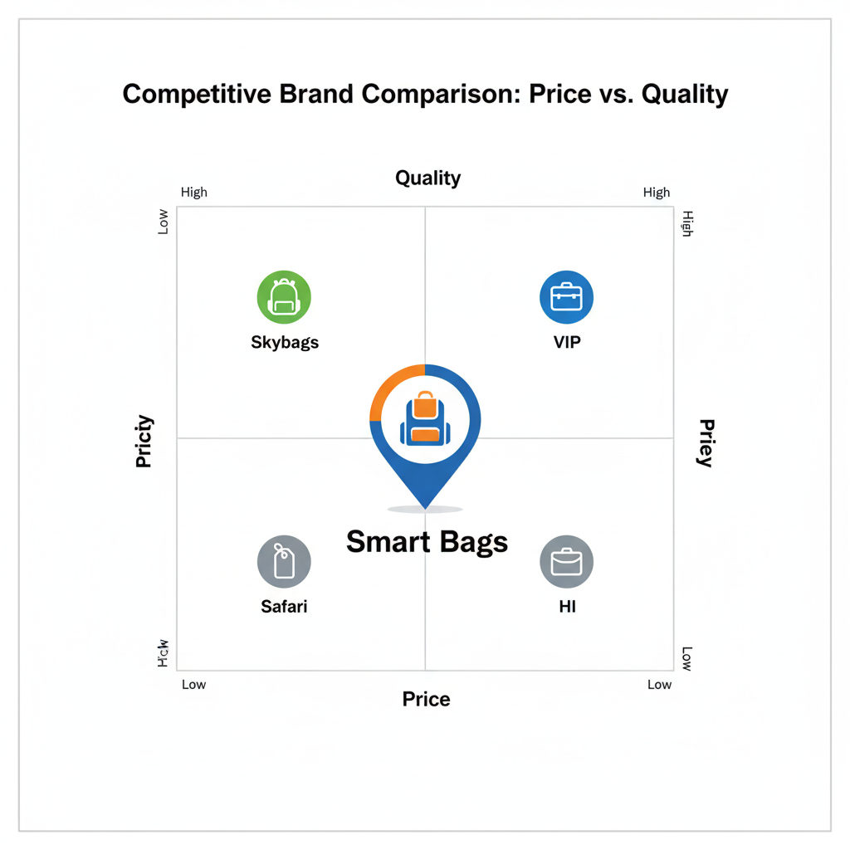

* **Marketing Mix**

1. Product Strategy -

Smart Bags is an excellent brand with a broad variety of durable, stylish, and functional items ready to address the requirements of students, travellers, and professionals. Product lines in the portfolio are school bags, college backpacks, travel bags, duffle bags, suitcases and a high-end designer line. Both products focus on comfort, durability, and beauty. Sustainability and innovation directed at the brand identity will be added with environmentally friendly materials and limited-edition collections. The physical features - logo, tagline, packaging, and mascot (Mr. SmartPack) are indicative of trustworthiness, local pride, and youthful vitality.

1. Price Strategy –

The brand adheres to a value-oriented tiered-pricing that offers a compromise of affordability and perceived quality. Prices of products are between 250 and 12,000, serving various classes of consumers. Smart Bags is between unbranded low-cost products and high-end national offerings such as the VIP or the Skybags. Pricing strategies that appeal to its customers include bundling offers, seasonal offers, and regional pricing to ensure that it remains competitive, and to keep buying again.

1. Place Strategy –

Smart totes operate an omnichannel distribution model to call a wide range of people. The physical presence comprises the flagship store bearing the title Bag Gallery in Ujjain and partnerships with schools, colleges, and local stores. The growth online via Amazon, Flipkart, Myntra, Ajio, and Tata CLiQ covers both metro and tier-2 urban centres. This hybrid structure establishes favour and confidence and expands the brand beyond the regional foundation.

1. Promotion Strategy –

The marketing strategy will incorporate both emotional narration and online interaction. The advertising campaigns like Express Yourself and Your First Bag, Forever Bag emphasize on durability, nostalgia, and personal identity. Brand ambassador Ranveer Singh reinforced youth appeal and credence. Social media marketing (#SmartDurabilityChallenge, #SmartStories), influencer collaborations and college activations generate significant hype online and offline. Offers on festival and local events strengthen local affiliation and brand recognition.

1. People Strategy –

Smart Bags can identify its employees, retailers and brand partners as most important ambassadors of its brand promise. Customer care and sales personnel are selected to live the brand values-approachability, honesty and reliability. Developing positive customer relationships and positive word-of-mouth promotion by establishing friendly relations with schools, colleges, and local communities, Smart Bags will make sure that customers have positive experiences and contribute to the promotion.

1. Process Strategy –

The brand concentrates on offering a smooth and direct shopping experience both at the physical and online touchpoints. The customers can browse products easily, make secure payments, have warranty services, and hassles free returns. Trust is increased through online tracking of order and delivery in time, whereas satisfaction and loyalty to online stores are achieved through in store personalization (monogramming or personal design).

1. Physical Evidence –

Smart Bags is certain that all physical touchpoints will always reflect the brand identity. Starting with its exuberant store interior design and environmentally friendly packaging to its unique brand logo, colour scheme (orange, royal blue) and promotional display signs - all these helps to enhance the visual integrity and quality promise of the brand. Experiential products: Even the flagship of the close-up section called Bag Gallery and selfie area are the artifacts attested to by the creative and customer-oriented image of the Smart Bags.

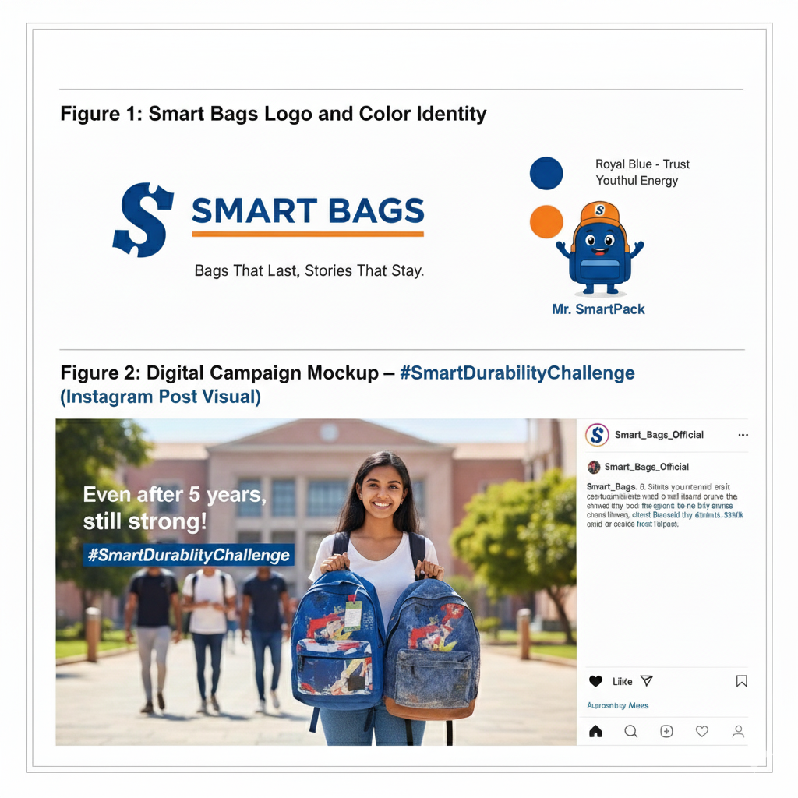

* **Smart Bag E-Commerce Strategy**

1. Justification of the E-Commerce Presence.

* As online shopping in India continues to grow, sharing Smart Bags with websites, such as Flipkart, Amazon, Myntra and Tata CLiQ can give the company a chance to:
* Expand the coverage to include markets outside of Ujjain to serve Mexico and metro and tier-

2 cities

* Grow college, travel and high-end bag segment.
* Use festive sales, discounts and web promotion.
* One should tap into the young, technology-friendly consumers, specifically the students and working population.
* Important Learning: most of the intermediate competitors are already present in the online stores. Offline restriction will reduce growth prospects. Adding Smart Bags to such websites would make the brand widely available nationwide, up to date, and user-friendly.

2. Recommended Platforms -

Amazon India

* High traffic and trust.
* Good in marketing as a school/college bag and or a travelling bag.
* Credibility can be created through prime delivery and customers reviews.

Flipkart

* High representation in the third and second tier cities.
* Perfect with low cost high-end and model bags.
* Promotes package deals and promotions.

Myntra / Ajio (Fashion-Focused)

* Reaches out to young people and students in colleges.
* Ideal match with fashionable and exclusive backpacks.
* Scrappy with celebrity endorsements and social media promotions.

Local E-Commerce Portals / Tata CLiQ.

* With high-end or luxury bags, sustainability bags.
* Framing background-powered limited editions.
* The use of e-commerce as a marketing tactic has received growing interest throughout the years as companies strive to gain a competitive edge via this approach.

3. Optimized Product Listings:

* Taking part in meaningful product description with an emphasis on durability, design, and the story of Smart Bags.
* Add screens, dimensions, compartments, warranty, USP -features.

Sponsored Ads & Campaigns:

* Flourish Amazon/ Flipkart ad tools in festivals and back-to-school season.
* Reach out to target parents, students and travellers through demographic and interest-based advertisements.

Customer Reviews & Ratings:

* BUS: invite buyers to post photos and testimonials.
* Publicly run incentives on the online version of Smart Stories, i.e., combining social proof and brand story.

Bundle Offers & Flash Sales:

* Examples: purchase a school bag, or college bag + water bottle.
* Establish a sense of urgency through time-based products on the festival.

4. Merging with Brand Identity -

* The company should be digitally native with e-commerce representation:
* The product images, banners, and package should have logo, colour palette, and a tagline of “Bags That Last, Stories That Stay.
* The e-commerce banners can be adapted to lifestyle shots and celebrity tie-ins (Ranveer Singh).
* Such special online collections as limited editions bags, green lines, regional art designs can be pointed out.

5. Expected Impact -

* More brand awareness and exposure nationwide.
* Improved selling of high margin goods such as travels and high-end bags.
* Enhanced credibility of brand by review, ratings and social proof.
* Co-branded with offline advertising, development of the inter-channel omnichannel brand image.

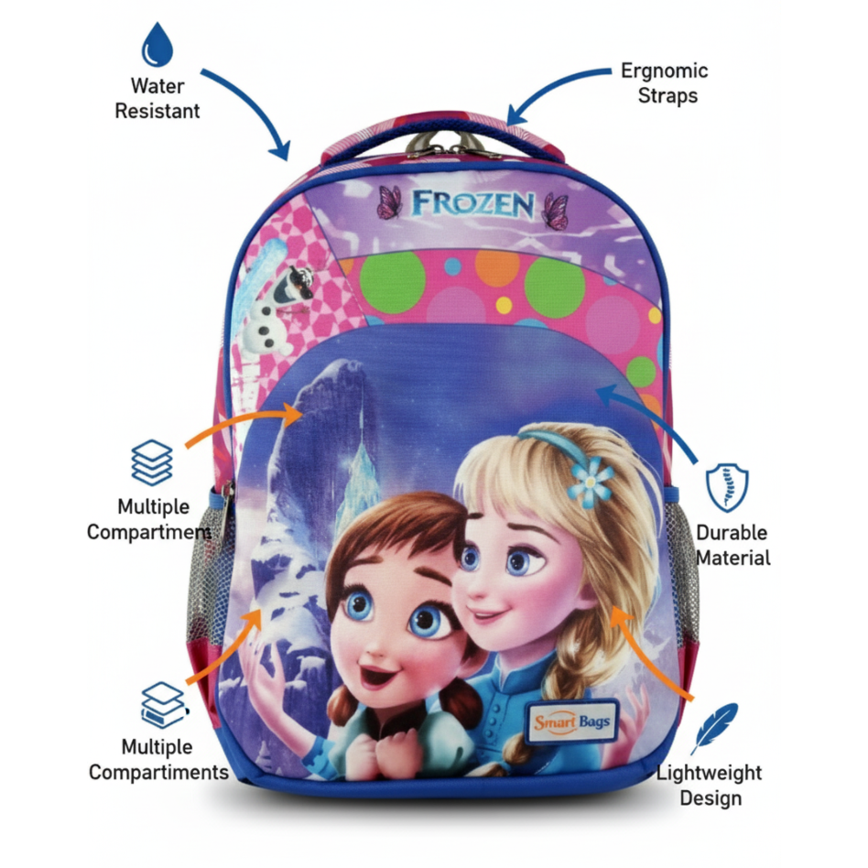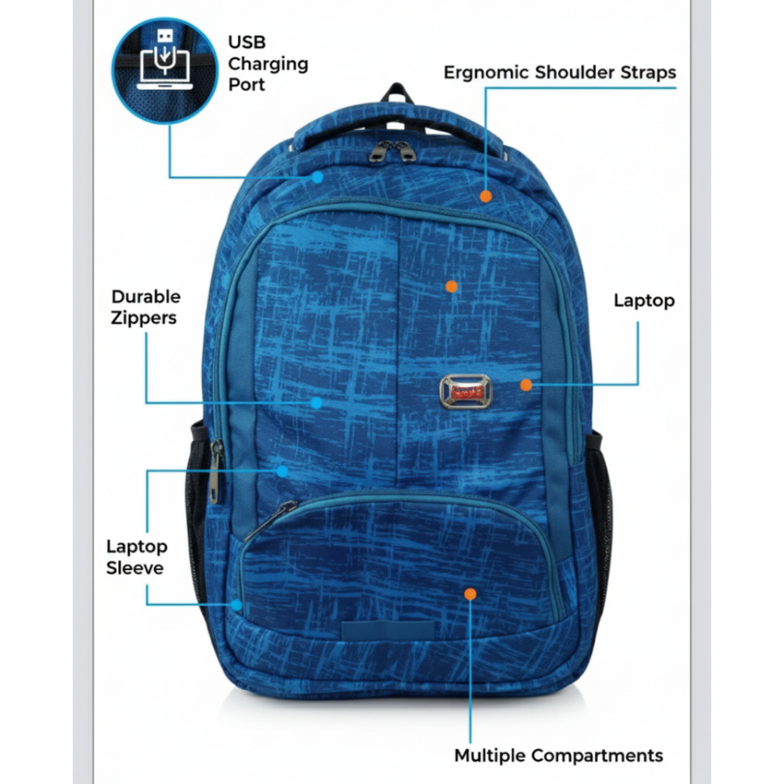

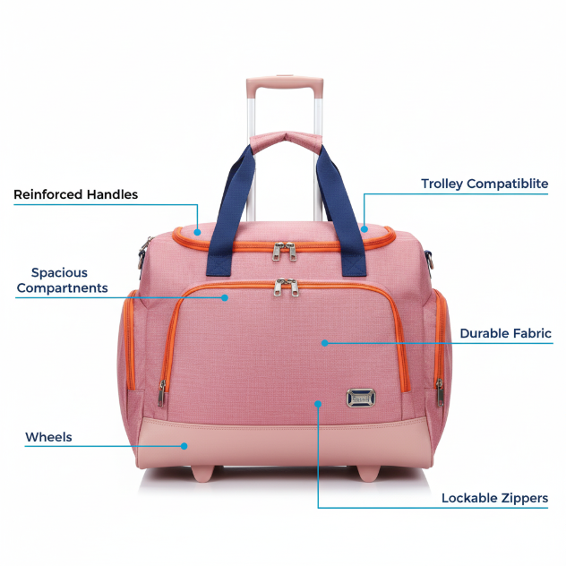

* **Recommendations -**

1. Core Competencies finds profitable regular market segments: school/ coll platform bags and travel bags during marketing, product maintenance, Digital Advertising.
2. Improve Emotional Response: Storytelling, nostalgia campaigning, and cause marketing will build long-term brand equity.
3. Cash in on the Name Recognition of Celebrities: Ranveer Singh meets the requirement of target group (younger generation) awakening awareness, credibility and cognizance in social media.
4. Extension into other regions: Ad branch into other regions within franchise or as B2B association with schools and colleges to attract more clients.
5. Product Advance/Premium Line: Premium products support brand wants, aspirational market customer desire due to limited production, environmentally friendly products and eco fabrics.
6. Sustainability & Corporate Social responsibility: (environmentally friendly products and donations program) build emotional and social wealth.

* Expected Outcome:
* From weak to expensive performance by a local player to a strong emotional appeal local brand.
* Details Increased sales, loyalty and brand awareness within each of the major segments.
* Gives a wide foundation towards future country development.